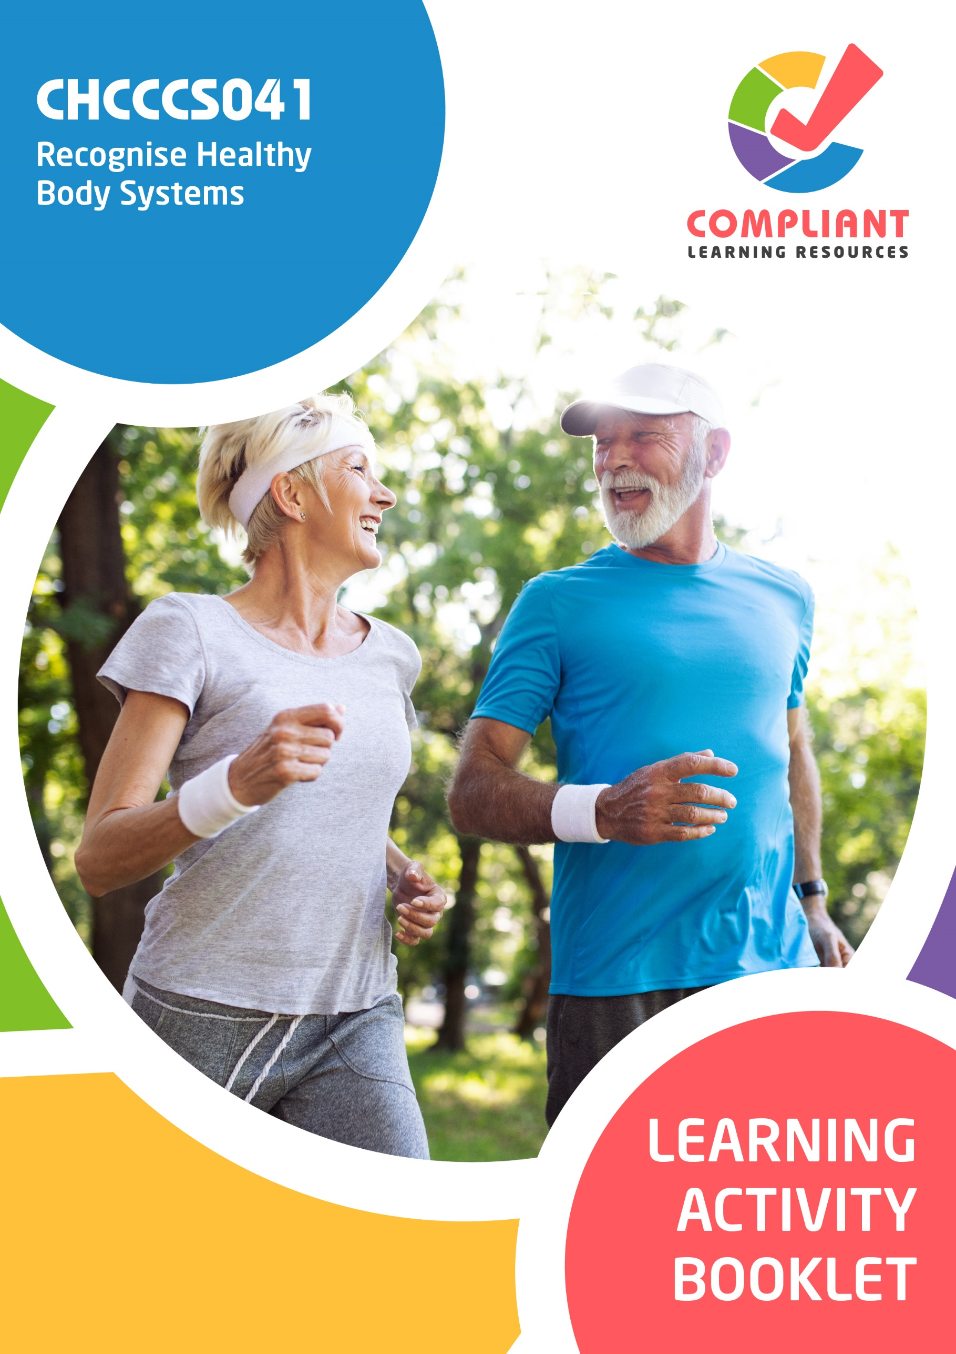

**Copyright**

This document was developed by Compliant Learning Resources.

© 2023 Compliant Learning Resources.

All rights reserved.

No part of this publication may be reproduced, stored in a retrieval system, or transmitted in any form or by any means, electronic, mechanical, photocopying, recording, or otherwise without the prior written permission of Compliant Learning Resources.

**Version Control & Document History**

|  |  |  |
| --- | --- | --- |
| **Date** | **Summary of Modifications** | **Version** |
| 13 January 2023 | Version 1.0 released for publishing | 1.0 |

# Table of Contents

Overview 4

Learner Instructions 5

Learner Information 5

Trainer Information 5

Resources Required 6

Work Health and Safety 6

Reasonable Adjustment 7

Formative Activities 8

I. Work With Information About the Human Body 8

Activity 1.1 8

Activity 1.2 9

Activity 1.3 10

Activity 1.4 12

II. Recognise and Promote Ways to Support Healthy Functioning of the Body 13

Activity 2.1 13

Activity 2.2 14

Activity 2.3 15

# Overview

**CHCCCS041 - Recognise healthy body systems (Release 1)**

This unit describes the performance outcomes, skills and knowledge required to work with basic information about healthy body systems and the impacts of ageing and disability.

This unit applies to workers across a range of community services contexts.

The skills in this unit must be applied in accordance with Commonwealth and State/Territory legislation, Australian standards and industry codes of practice.

No occupational licensing, certification or specific legislative requirements apply to this unit at the time of publication.

**A complete copy of the above unit of competency can be downloaded from the TGA website:**

<https://training.gov.au/Training/Details/CHCCCS041>

# Learner Instructions

This Learning Activity Booklet contains formative activities that learners will complete in the classroom or a similar environment.

These formative activities include knowledge questions to test your underpinning generic knowledge and practical activities to test your skills relevant to the unit/s of competency.

These formative assessments are used by your trainer to complement both the learning and training processes, and to evaluate how you are progressing throughout these processes.

You may reference your Learner Guide and other learning materials to complete the activities included in this workbook.

**IMPORTANT:**

**The completion of the formative assessments and learning activities included in this workbook DOES NOT lead to a Qualification or a Statement of Attainment (SOA).**

## Learner Information

|  |  |
| --- | --- |
| Learner name |  |
| Phone |  |
| Email |  |

## Trainer Information

|  |  |
| --- | --- |
| Trainer name |  |
| RTO name |  |
| RTO phone |  |
| RTO email |  |

# Resources Required

Resources needed to complete activities included in this workbook include:

* Computer with Internet, email access, and a working web browser
* Installed software: MS Word, Adobe Acrobat Reader
* Learner guide

# Work Health and Safety

Both the trainers and learners have duty of care in ensuring that the learning environment is free from hazards that may pose risks to their health and safety.

According to WHS legislation, trainers and learners must take reasonable care while undertaking the activities included in this workbook in the learning environment.

# Reasonable Adjustment

‘Reasonable adjustment’ in VET is the term applied to modifying the learning environment or making changes to the training delivered to assist a learner with a disability. A reasonable adjustment can be as simple as changing classrooms to be closer to amenities or installing a particular type of software on a computer for a person with vision impairment.

**Why make a reasonable adjustment?**

We make reasonable adjustments in VET to make sure that learners with disabilities have:

* The same learning opportunities as learners without disabilities, and
* The same opportunity to perform and complete assessments as those without disabilities.

**Reasonable adjustment applied to participation in teaching, learning, and assessment activities can include:**

* Customising resources and assessment activities within the training package or accredited course
* Modifying the presentation medium
* Learner support
* Use of assistive/adaptive technologies
* Making information accessible both before enrolment and during the course
* Monitoring the adjustments to ensure learner needs continue to be met

**Assistive/Adaptive Technologies**

Assistive/adaptive technology means ‘software or hardware that has been specifically designed to assist people with disabilities in carrying out daily activities’ (World Wide Web Consortium - W3C). It includes screen readers, magnifiers, voice recognition software, alternative keyboards, devices for grasping, visual alert systems, and digital note-takers.

*(Adapted Reasonable Adjustment in teaching, learning and assessment for learners with a disability - November 2010 - Prepared by - Queensland VET Development Centre)*

**IMPORTANT:**

**Reasonable adjustment made for collecting learner assessment evidence must not impact the standard expected by the workplace, as expressed by the relevant unit/s of competency. For example, if the assessment were gathering evidence of the learner’s competency in writing, allowing the learner to complete the assessment verbally would not be a valid assessment method. The method of assessment used by any reasonable adjustment must still meet the competency requirements.**

# Formative Activities

## I. Work With Information About the Human Body

### Activity 1.1

|  |  |
| --- | --- |
| **True or False**  Review the statements below about different body systems. Indicate whether each statement is True or False.  Tick the box that corresponds to your answer. | |
|  | |
| TRUE  FALSE | 1. The cardiovascular system is responsible for transporting oxygen, blood cells, water and nutrients around the body. |
| TRUE  FALSE | 1. The respiratory system is responsible for giving structure and providing the body with the right amount of blood cells. It also facilitates movement and locomotion. |
| TRUE  FALSE | 1. The reproductive system serves as defence against bacteria, pollution, and harmful UV rays from the sun. |
| TRUE  FALSE | 1. The spinal cord links the brain and the peripheral nervous system (PNS). |
| TRUE  FALSE | 1. The nose gives the body a sense of equilibrium or the sense that gives humans an idea about the position of the body. |

### Activity 1.2

|  |  |  |  |
| --- | --- | --- | --- |
| **Matching Type**  Shown below is the diagram of the parts of the digestive system.  Identify each numbered part by selecting your answer from the drop-down list below. | | | |
|  | | | |
|  | | | |
| **1** | Choose an item. | **6** | Choose an item. |
| **2** | Choose an item. | **7** | Choose an item. |
| **3** | Choose an item. | **8** | Choose an item. |
| **4** | Choose an item. | **9** | Choose an item. |
| **5** | Choose an item. | **10** | Choose an item. |

### Activity 1.3

|  |
| --- |
| **SCENARIO**  Friday, 11 March 20xx, 8:00 AM  *Where 20xx refers to the current year*  Madge has been in your care since she arrived at the centre two years ago. However, you have been away on holiday for the last two months, so another support worker had to be assigned to care for Madge.  On your first day back, as you and another individual support worker were about to hoist her from the bed and onto her wheelchair, you noticed that Madge had sore, purple discoloured and painful spots about 8cm across on both her shoulders and a smaller one about 3cm across on the backside of her head.  When she was on her side, you saw some bleeding through her pants and on the bedsheets from the upper part of her buttocks. It appears it has not been checked for at least a day or two. Her bed sheets were stained and smelled of faeces and urine. She looked in pain. You asked her if you could check what was causing her pain. You found that she had an open wound about 2cm across, and the skin surrounding it was very red and discoloured. Madge cringed in pain as you gently assessed the condition of her skin.  You later found out that she has not been out of her bed in two days. You asked her why she has not gone out of her bed, and she told you that she is just feeling too tired lately and going out just takes too much effort. She asked you if she could just stay in bed and rest today. You noticed that she seems withdrawn. You also noticed that she has lost a lot of weight since the last time you saw her about two months ago.  Madge asked you if you could get medication to help her with the pain. She started feeling pain in her buttocks and both shoulders two days ago but did not tell anyone until you were back from your leave. When you asked her why she did not tell anyone about it, she said she did not want to bother the nurse. This made you worry about Madge and asked her if there was anything else that was bothering her. You found out that she has not had any bowel movement in two days, and urinating has started to become painful for her.  She asked if you could clean her wounds and give her pain medication. You explained to her that although you would love to help her, you are not qualified to perform those procedures on clients. You checked her care plan and found that her nurse’s name is Olivia. You explained to Madge that registered nurse Olivia would be the best person to clean her wounds and help her manage her pain with medication as prescribed by her doctor.  Madge appeared nervous and anxious when you mentioned the nurse’s name. She hesitantly tells you that the pain is gone, and she feels fine. She tells you she does not need the pain medication anymore. |

|  |
| --- |
| Below is a Progress Notes template. Complete the template below by:   1. Identifying the date and time 2. Identifying three indicators of change with the client's condition 3. Providing action items on what needs to be done for each indicator identified |

|  |  |  |
| --- | --- | --- |
| **Date** | **Status** | **Action point** |
|  |  |  |
|  |  |
|  |  |

*Add rows as necessary*

### Activity 1.4

|  |
| --- |
| List three ways on how health-related terminologies and abbreviations relevant to body systems can help you in performing your work role. |
|  |
|  |
|  |
|  |

## II. Recognise and Promote Ways to Support Healthy Functioning of the Body

### Activity 2.1

|  |  |
| --- | --- |
| **Matching Type**  Listed below are different factors that contribute to the overall health of a person’s body:   1. Nutrition 2. Hydration 3. Skin integrity 4. Movement 5. Social interaction   Match each factor to the resources below that are used to review the client's medical history and clinical status. Write the letter that corresponds to your answer in the space provided. | |
|  | |
| Resources to Review | |
|  | 1. Physical therapy assessment documentation, medical history (to check for previous injuries) |
|  | 1. Nutrition assessments, food diary, etc. |
|  | 1. Vital signs, fluid balance chart, daily weight chart, fluid prescription chart, surgical documentation (if the client is post-op) |
|  | 1. Pressure Ulcers Clinical Data Collection Form or other similar documents |
|  | 1. Psychological reports, geriatric functional assessment documentation, etc. |

### Activity 2.2

|  |  |  |  |  |  |  |  |
| --- | --- | --- | --- | --- | --- | --- | --- |
| **Matching Type**  Identify the allied health professional being described in each statement below.   |  | | --- | | **Multidisciplinary Health Professionals** | | Physical therapists | | Speech pathologists | | Respiratory therapists | | Clinical nutritionists | | Pharmacists | | |
|  | |
| Description | |
|  | 1. These are professionals who help improve or restore physical functioning, such as strength or movement of the client. |
|  | 1. These are professionals who work with individual clients to ensure they get proper nutrition based on their medical condition. |
|  | 1. These are professionals who provide advice on how to use medicine safely. They also offer a range of services, including healthcare advice, vaccinations, self-care and lifestyle assessments and provide medical certificates. |
|  | 1. These are professionals who help improve or restore speech of clients who have had illnesses that affected their speech. |
|  | 1. These are professionals who administer medication, set up and monitor life support equipment such as ventilators, and teach patients how to manage chronic lung disorders. |

### Activity 2.3

|  |
| --- |
| List down four ways to avoid infecting elderly and disabled clients. |
|  |
|  |
|  |
|  |
|  |

End of Document